

Asignatura

Base de Datos 1

BdMife

Presenta

Milena Giraldo Vergara

Docente

Javier Ospina

BASE DE DATOS MIFE

## Planteamiento del problema

El problema que voy darle solución es a varios inconveniente que se presentan en MIFE, entre ellos la mala administración en la mercancía; logrando así agilizar los procesos en los reportes de existencias, de producto, de ventas, clientes ya que no solo es en MIFE sino en muchos establecimientos comerciales que manejan mercancía y presentan el mismo problema.

DIAGRAMA RELACIONAL

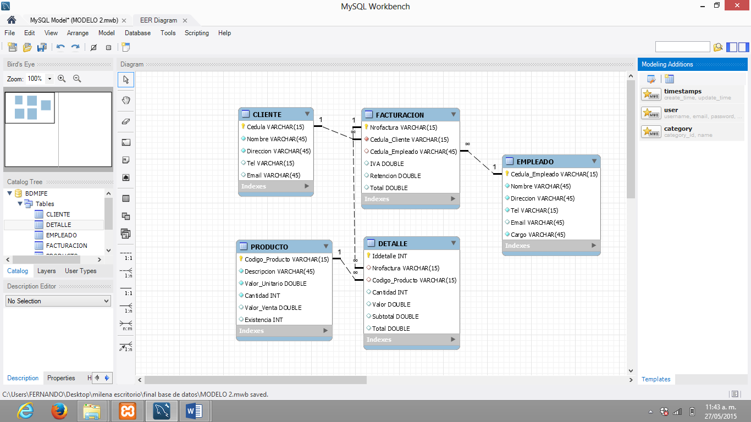

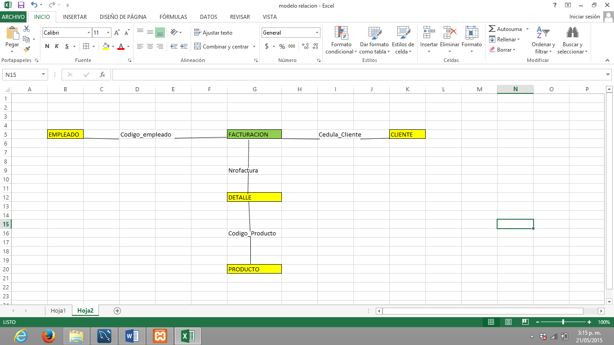

LISTA TABLAS

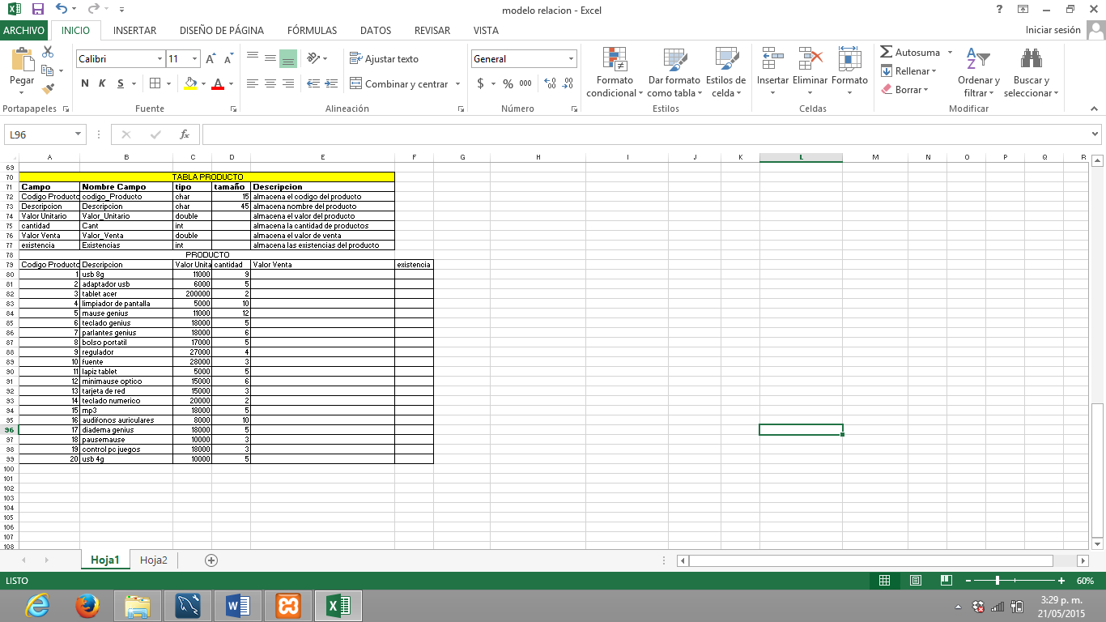

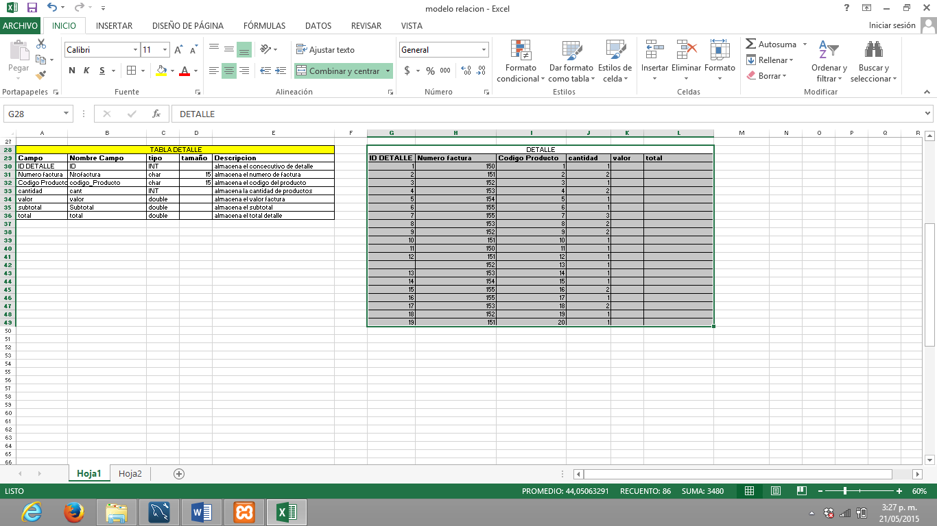

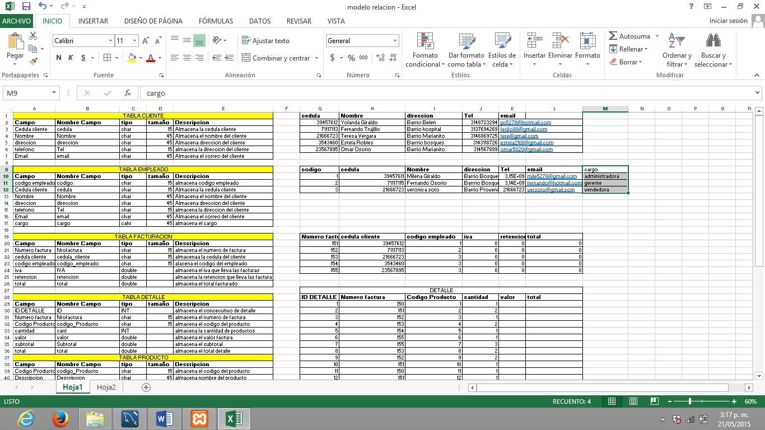

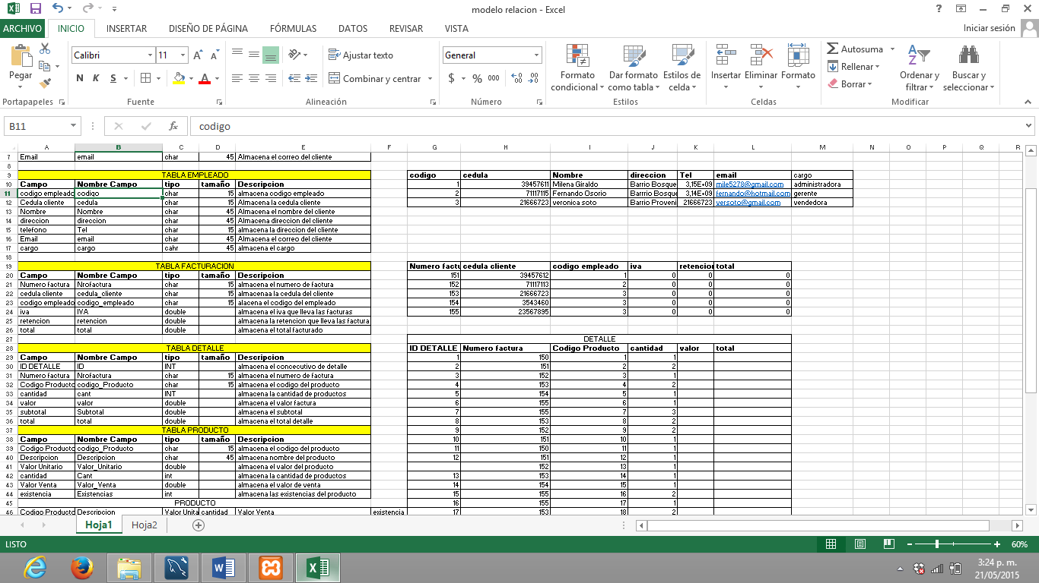

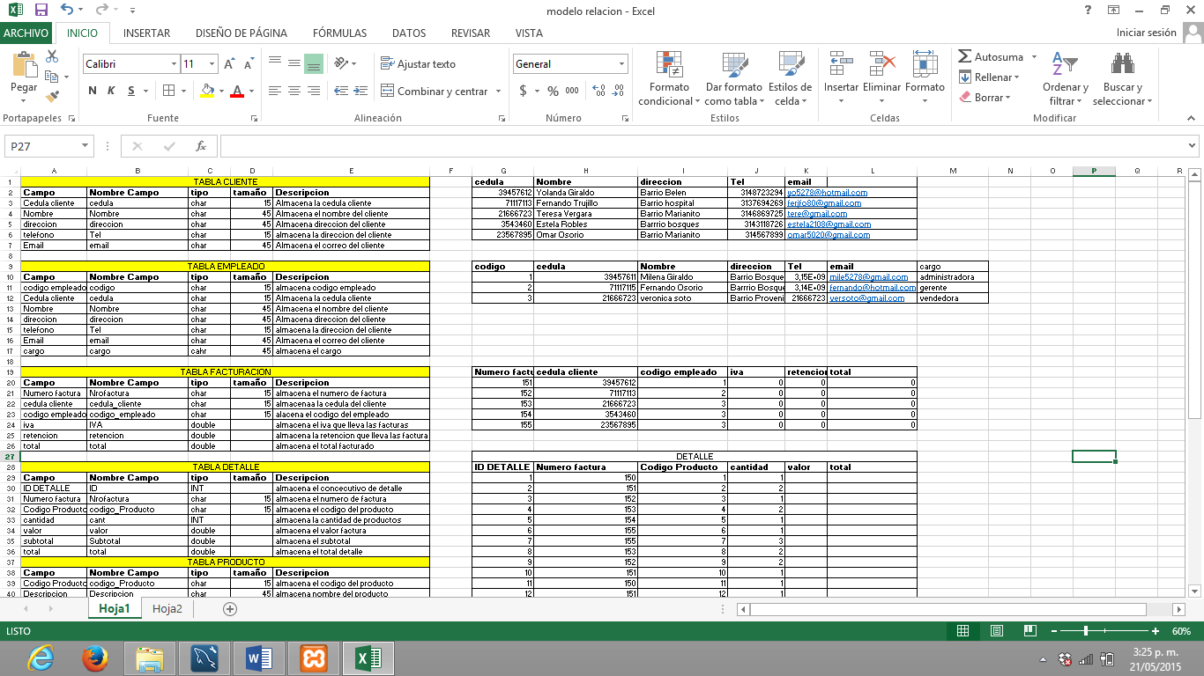

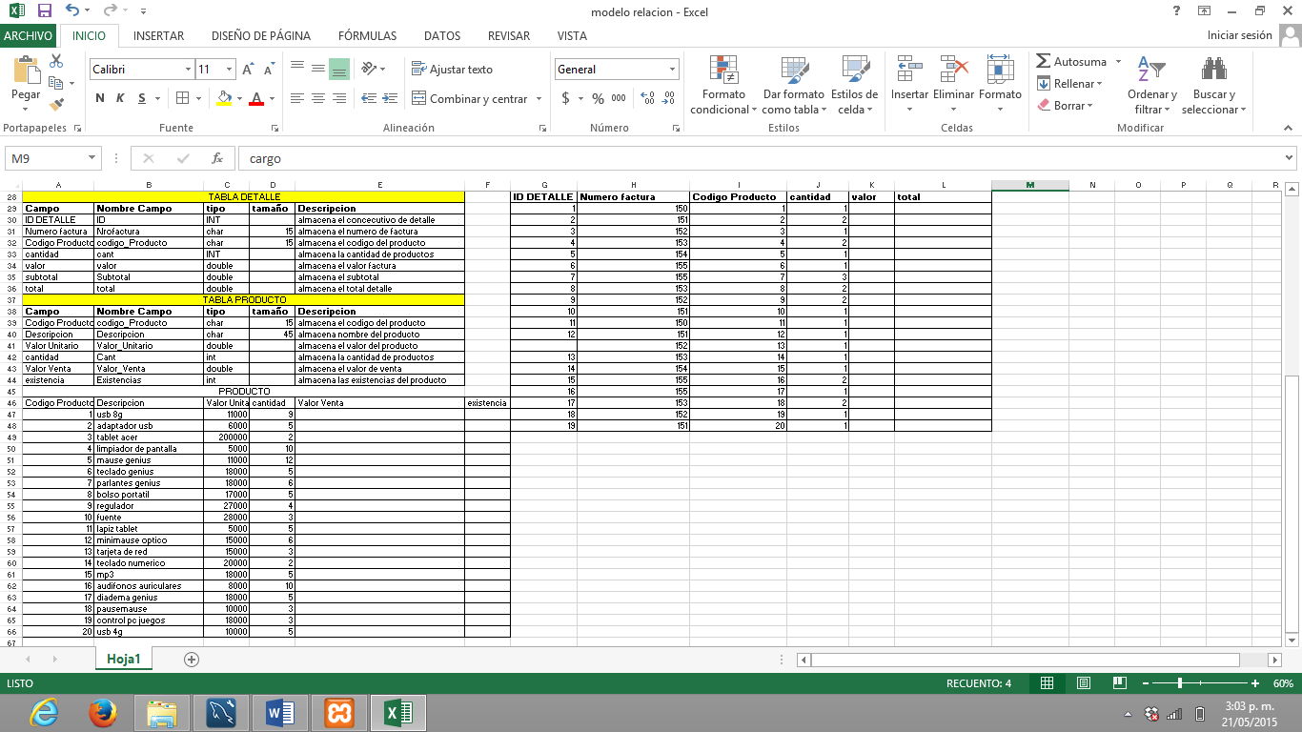

Comandos

table `bdmife`.`cliente`

-- -----------------------------------------------------

create table if not exists `bdmife`.`cliente` (

`cedula` varchar(15) not null,

`nombre` varchar(45) not null,

`direccion` varchar(45) not null,

`tel` varchar(15) null,

`email` varchar(45) null,

primary key (`cedula`))

engine = innodb;

-- -----------------------------------------------------

-- table `bdmife`.`empleado`

-- -----------------------------------------------------

create table if not exists `bdmife`.`empleado` (

`cedula_empleado` varchar(15) not null,

`nombre` varchar(45) not null,

`direccion` varchar(45) not null,

`tel` varchar(15) not null,

`email` varchar(45) null,

`cargo` varchar(45) not null,

primary key (`cedula_empleado`))

engine = innodb;

-- -----------------------------------------------------

-- table `bdmife`.`facturacion`

-- -----------------------------------------------------

create table if not exists `bdmife`.`facturacion` (

`nrofactura` varchar(15) not null,

`cedula_cliente` varchar(15) not null,

`cedula_empleado` varchar(45) null,

`iva` double null,

`retencion` double null,

`total` double null,

primary key (`nrofactura`),

index `cedula_cliente_idx` (`cedula_cliente` asc),

index `cedula_empleado_idx` (`cedula_empleado` asc),

constraint `cedula_cliente`

foreign key (`cedula_cliente`)

references `bdmife`.`cliente` (`cedula`)

constraint `cedula_empleado`

foreign key (`cedula_empleado`)

references `bdmife`.`empleado` (`cedula_empleado`)

engine = innodb;

-- -----------------------------------------------------

-- table `bdmife`.`producto`

-- -----------------------------------------------------

create table if not exists `bdmife`.`producto` (

`codigo_producto` varchar(15) not null,

`descripcion` varchar(45) not null,

`valor_unitario` double not null,

`cantidad` int not null,

`valor_venta` double null,

`existencia` int null,

primary key (`codigo_producto`))

engine = innodb;

-- -----------------------------------------------------

-- table `bdmife`.`detalle`

-- -----------------------------------------------------

create table if not exists `bdmife`.`detalle` (

`iddetalle` int not null auto_increment,

`nrofactura` varchar(15) null,

`codigo_producto` varchar(15) null,

`cantidad` int null,

`valor` double null,

`subtotal` double null,

`total` double null,

primary key (`iddetalle`),

index `codigo_producto_idx` (`codigo_producto` asc),

index `nrofactura_idx` (`nrofactura` asc),

constraint `codigo_producto`

foreign key (`codigo_producto`)

references `bdmife`.`producto` (`codigo_producto`)

constraint `nrofactura`

foreign key (`nrofactura`)

engine = innodb;

set sql_mode=@old_sql_mode;

set foreign_key_checks=@old_foreign_key_checks;

set unique_checks=@old_unique_checks;

ysql> show tables;

+------------------+

| Tables_in_bdmife |

+------------------+

| cliente |

| detalle |

| empleado |

| facturacion |

| producto |

+------------------+

5 rows in set (0.00 sec)

mysql> describe cliente;

+-----------+-------------+------+-----+---------+-------+

| Field | Type | Null | Key | Default | Extra |

+-----------+-------------+------+-----+---------+-------+

| Cedula | varchar(15) | NO | PRI | NULL | |

| Nombre | varchar(45) | NO | | NULL | |

| Direccion | varchar(45) | NO | | NULL | |

| Tel | varchar(15) | YES | | NULL | |

| Email | varchar(45) | YES | | NULL | |

+-----------+-------------+------+-----+---------+-------+

5 rows in set (0.03 sec)

mysql> select * from cliente;

+----------+-----------------+------------------+------------+-------------------------+

| Cedula | Nombre | Direccion | Tel | Email |

+----------+-----------------+------------------+------------+-------------------------+

| 21666723 | Teresa Vergara | Barrio Marianito | 3146869725 | Teresa@gamil.com |

| 23567895 | Omar Osorio | Barrio Marianito | 3128769345 | lida@hotmail.com |

| 35434601 | Estela Robles | Barrio Bosques | 3148689787 | el2162@gmail.com |

| 39457611 | yolanda Giraldo | Barrio Belen | 3148723294 | yo5278@gmail.com |

| 71117113 | Fernando Osorio | Barrio hospital | 3137694269 | fernandojfo@hotmail.com |

+----------+-----------------+------------------+------------+-------------------------+

5 rows in set (0.30 sec)

mysql> alter table cliente add Tel2 char(15)not null after Tel;

Query OK, 0 rows affected (0.55 sec)

Records: 0 Duplicates: 0 Warnings: 0

mysql> select * from cliente;

+----------+-----------------+------------------+------------+------+-------------------------+

| Cedula | Nombre | Direccion | Tel | Tel2 | Email |

+----------+-----------------+------------------+------------+------+-------------------------+

| 21666723 | Teresa Vergara | Barrio Marianito | 3146869725 | | Teresa@gamil.com |

| 23567895 | Omar Osorio | Barrio Marianito | 3128769345 | | lida@hotmail.com |

| 35434601 | Estela Robles | Barrio Bosques | 3148689787 | | el2162@gmail.com |

| 39457611 | yolanda Giraldo | Barrio Belen | 3148723294 | | yo5278@gmail.com |

| 71117113 | Fernando Osorio | Barrio hospital | 3137694269 | | fernandojfo@hotmail.com |

+----------+-----------------+------------------+------------+------+-------------------------+

5 rows in set (0.00 sec)

mysql> alter table cliente drop Tel2;

Query OK, 0 rows affected (0.50 sec)

Records: 0 Duplicates: 0 Warnings: 0

mysql> select * from cliente;

+----------+-----------------+------------------+------------+-------------------------+

| Cedula | Nombre | Direccion | Tel | Email |

+----------+-----------------+------------------+------------+-------------------------+

| 21666723 | Teresa Vergara | Barrio Marianito | 3146869725 | Teresa@gamil.com |

| 23567895 | Omar Osorio | Barrio Marianito | 3128769345 | lida@hotmail.com |

| 35434601 | Estela Robles | Barrio Bosques | 3148689787 | el2162@gmail.com |

| 39457611 | yolanda Giraldo | Barrio Belen | 3148723294 | yo5278@gmail.com |

| 71117113 | Fernando Osorio | Barrio hospital | 3137694269 | fernandojfo@hotmail.com |

+----------+-----------------+------------------+------------+-------------------------+

5 rows in set (0.00 sec)

mysql> alter table cliente change Tel telefono char(15) not null;

Query OK, 5 rows affected (1.14 sec)

Records: 5 Duplicates: 0 Warnings: 0

mysql> select * from cliente;

+----------+-----------------+------------------+------------+-------------------------+

| Cedula | Nombre | Direccion | telefono | Email |

+----------+-----------------+------------------+------------+-------------------------+

| 21666723 | Teresa Vergara | Barrio Marianito | 3146869725 | Teresa@gamil.com |

| 23567895 | Omar Osorio | Barrio Marianito | 3128769345 | lida@hotmail.com |

| 35434601 | Estela Robles | Barrio Bosques | 3148689787 | el2162@gmail.com |

| 39457611 | yolanda Giraldo | Barrio Belen | 3148723294 | yo5278@gmail.com |

| 71117113 | Fernando Osorio | Barrio hospital | 3137694269 | fernandojfo@hotmail.com |

+----------+-----------------+------------------+------------+-------------------------+

5 rows in set (0.00 sec)

mysql> create table proveedor

-> (cedula char(15) not null primary key)

-> ;

Query OK, 0 rows affected (0.23 sec)

Eliminar tablas

mysql> drop table proveedor;

Query OK, 0 rows affected (0.13 sec)

mysql> // precios

mysql> select * from producto;

+-----------------+-----------------------+----------------+----------+-------------+------------+

| Codigo_Producto | Descripcion | Valor_Unitario | Cantidad | Valor_Venta | Existencia |

+-----------------+-----------------------+----------------+----------+-------------+------------+

| 1 | usb 8g | 11000 | 9 | 0 | 0 |

| 10 | fuente | 28000 | 3 | NULL | NULL |

| 11 | lapiz tablet | 5000 | 5 | NULL | NULL |

| 12 | minimause optico | 15000 | 6 | NULL | NULL |

| 13 | tarjeta de red | 15000 | 3 | NULL | NULL |

| 14 | teclado numerico | 20000 | 2 | NULL | NULL |

| 15 | mp3 | 18000 | 5 | NULL | NULL |

| 16 | audifonos auriculares | 8000 | 10 | NULL | NULL |

| 17 | diadema genius | 18000 | 5 | NULL | NULL |

| 18 | pause mause | 10000 | 3 | NULL | NULL |

| 19 | control pc juegos | 18000 | 3 | NULL | NULL |

| 2 | adaptador usb | 6000 | 5 | 0 | 0 |

| 20 | usb 4G | 10000 | 5 | NULL | NULL |

| 3 | tablet acer | 200000 | 2 | NULL | NULL |

| 4 | limpiador de pantalla | 5000 | 10 | NULL | NULL |

| 5 | mause genius | 11000 | 12 | NULL | NULL |

| 6 | teclado genius | 18000 | 5 | NULL | NULL |

| 7 | parlantes genius | 18000 | 6 | NULL | NULL |

| 8 | bolso portatil | 17000 | 5 | NULL | NULL |

| 9 | regulador | 27000 | 4 | NULL | NULL |

+-----------------+-----------------------+----------------+----------+-------------+------------+

20 rows in set (0.31 sec)

mysql> select sum(Valor_Unitario)from producto;

+---------------------+

| sum(Valor_Unitario) |

+---------------------+

| 478000 |

+---------------------+

1 row in set (0.00 sec)

mysql> select max(Valor_Unitario) from producto;

+---------------------+

| max(Valor_Unitario) |

+---------------------+

| 200000 |

+---------------------+

1 row in set (0.00 sec)

mysql> select avg(Valor_Unitario) from producto;

+---------------------+

| avg(Valor_Unitario) |

+---------------------+

| 23900 |

+---------------------+

1 row in set (0.00 sec)

mysql> select valor_unitario from producto;

+----------------+

| valor_unitario |

+----------------+

| 11000 |

| 28000 |

| 5000 |

| 15000 |

| 15000 |

| 20000 |

| 18000 |

| 8000 |

| 18000 |

| 10000 |

| 18000 |

| 6000 |

| 10000 |

| 200000 |

| 5000 |

| 11000 |

| 18000 |

| 18000 |

| 17000 |

| 27000 |

+----------------+

20 rows in set (0.00 sec)

mysql> select sum(Valor_Unitario)Valor_total from producto;

+-------------+

| Valor_total |

+-------------+

| 478000 |

+-------------+

1 row in set (0.00 sec)

mysql> select max(Valor_Unitario)'Producto mas costoso' from producto;

+----------------------+

| Producto mas costoso |

+----------------------+

| 200000 |

+----------------------+

1 row in set (0.00 sec)

mysql> select max(Valor_Unitario)'Producto menos costoso' from producto;

+------------------------+

| Producto menos costoso |

+------------------------+

| 200000 |

+------------------------+

1 row in set (0.00 sec)

mysql> select min(Valor_Unitario)'Producto menos costoso' from producto;

+------------------------+

| Producto menos costoso |

+------------------------+

| 5000 |

+------------------------+

1 row in set (0.00 sec)

mysql> select * from producto;

+-----------------+-----------------------+----------------+----------+-------------+------------+

| Codigo_Producto | Descripcion | Valor_Unitario | Cantidad | Valor_Venta | Existencia |

+-----------------+-----------------------+----------------+----------+-------------+------------+

| 1 | usb 8g | 11000 | 9 | 0 | 0 |

| 10 | fuente | 28000 | 3 | NULL | NULL |

| 11 | lapiz tablet | 5000 | 5 | NULL | NULL |

| 12 | minimause optico | 15000 | 6 | NULL | NULL |

| 13 | tarjeta de red | 15000 | 3 | NULL | NULL |

| 14 | teclado numerico | 20000 | 2 | NULL | NULL |

| 15 | mp3 | 18000 | 5 | NULL | NULL |

| 16 | audifonos auriculares | 8000 | 10 | NULL | NULL |

| 17 | diadema genius | 18000 | 5 | NULL | NULL |

| 18 | pause mause | 10000 | 3 | NULL | NULL |

| 19 | control pc juegos | 18000 | 3 | NULL | NULL |

| 2 | adaptador usb | 6000 | 5 | 0 | 0 |

| 20 | usb 4G | 10000 | 5 | NULL | NULL |

| 3 | tablet acer | 200000 | 2 | NULL | NULL |

| 4 | limpiador de pantalla | 5000 | 10 | NULL | NULL |

| 5 | mause genius | 11000 | 12 | NULL | NULL |

| 6 | teclado genius | 18000 | 5 | NULL | NULL |

| 7 | parlantes genius | 18000 | 6 | NULL | NULL |

| 8 | bolso portatil | 17000 | 5 | NULL | NULL |

| 9 | regulador | 27000 | 4 | NULL | NULL |

+-----------------+-----------------------+----------------+----------+-------------+------------+

20 rows in set (0.00 sec)

mysql> update producto set Cantidad=9 where Codigo_Producto='20';

Query OK, 1 row affected (0.05 sec)

Rows matched: 1 Changed: 1 Warnings: 0

mysql> select * from producto;

+-----------------+-----------------------+----------------+----------+-------------+------------+

| Codigo_Producto | Descripcion | Valor_Unitario | Cantidad | Valor_Venta | Existencia |

+-----------------+-----------------------+----------------+----------+-------------+------------+

| 1 | usb 8g | 11000 | 9 | 0 | 0 |

| 10 | fuente | 28000 | 3 | NULL | NULL |

| 11 | lapiz tablet | 5000 | 5 | NULL | NULL |

| 12 | minimause optico | 15000 | 6 | NULL | NULL |

| 13 | tarjeta de red | 15000 | 3 | NULL | NULL |

| 14 | teclado numerico | 20000 | 2 | NULL | NULL |

| 15 | mp3 | 18000 | 5 | NULL | NULL |

| 16 | audifonos auriculares | 8000 | 10 | NULL | NULL |

| 17 | diadema genius | 18000 | 5 | NULL | NULL |

| 18 | pause mause | 10000 | 3 | NULL | NULL |

| 19 | control pc juegos | 18000 | 3 | NULL | NULL |

| 2 | adaptador usb | 6000 | 5 | 0 | 0 |

| 20 | usb 4G | 10000 | 9 | NULL | NULL |

| 3 | tablet acer | 200000 | 2 | NULL | NULL |

| 4 | limpiador de pantalla | 5000 | 10 | NULL | NULL |

| 5 | mause genius | 11000 | 12 | NULL | NULL |

| 6 | teclado genius | 18000 | 5 | NULL | NULL |

| 7 | parlantes genius | 18000 | 6 | NULL | NULL |

| 8 | bolso portatil | 17000 | 5 | NULL | NULL |

| 9 | regulador | 27000 | 4 | NULL | NULL |

+-----------------+-----------------------+----------------+----------+-------------+------------+

20 rows in set (0.00 sec)

mysql> select(Valor_Unitario*Cantidad)'Valor Total Cantidad Productos' from producto;

+--------------------------------+

| Valor Total Cantidad Productos |

+--------------------------------+

| 99000 |

| 84000 |

| 25000 |

| 90000 |

| 45000 |

| 40000 |

| 90000 |

| 80000 |

| 90000 |

| 30000 |

| 54000 |

| 30000 |

| 90000 |

| 400000 |

| 50000 |

| 132000 |

| 90000 |

| 108000 |

| 85000 |

| 108000 |

+--------------------------------+

20 rows in set (0.00 sec)

mysql> update producto set descripcion='usb 8g Kingston' where Codigo_producto='1';

Query OK, 1 row affected (0.36 sec)

Rows matched: 1 Changed: 1 Warnings: 0

mysql> select * from producto;

+-----------------+-----------------------+----------------+----------+-------------+------------+

| Codigo_Producto | Descripcion | Valor_Unitario | Cantidad | Valor_Venta | Existencia |

+-----------------+-----------------------+----------------+----------+-------------+------------+

| 1 | usb 8g Kingston | 11000 | 9 | 0 | 0 |

| 10 | fuente | 28000 | 3 | NULL | NULL |

| 11 | lapiz tablet | 5000 | 5 | NULL | NULL |

| 12 | minimause optico | 15000 | 6 | NULL | NULL |

| 13 | tarjeta de red | 15000 | 3 | NULL | NULL |

| 14 | teclado numerico | 20000 | 2 | NULL | NULL |

| 15 | mp3 | 18000 | 5 | NULL | NULL |

| 16 | audifonos auriculares | 8000 | 10 | NULL | NULL |

| 17 | diadema genius | 18000 | 5 | NULL | NULL |

| 18 | pause mause | 10000 | 3 | NULL | NULL |

| 19 | control pc juegos | 18000 | 3 | NULL | NULL |

| 2 | adaptador usb | 6000 | 5 | 0 | 0 |

| 20 | usb 4G | 10000 | 9 | NULL | NULL |

| 3 | tablet acer | 200000 | 2 | NULL | NULL |

| 4 | limpiador de pantalla | 5000 | 10 | NULL | NULL |

| 5 | mause genius | 11000 | 12 | NULL | NULL |

| 6 | teclado genius | 18000 | 5 | NULL | NULL |

| 7 | parlantes genius | 18000 | 6 | NULL | NULL |

| 8 | bolso portatil | 17000 | 5 | NULL | NULL |

| 9 | regulador | 27000 | 4 | NULL | NULL |

+-----------------+-----------------------+----------------+----------+-------------+------------+

20 rows in set (0.00 sec)

mysql> select * from producto where cantidad>15;

Empty set (0.00 sec)

mysql> select * from Producto where cantidad<15;

+-----------------+-----------------------+----------------+----------+-------------+------------+

| Codigo_Producto | Descripcion | Valor_Unitario | Cantidad | Valor_Venta | Existencia |

+-----------------+-----------------------+----------------+----------+-------------+------------+

| 1 | usb 8g Kingston | 11000 | 9 | 0 | 0 |

| 10 | fuente | 28000 | 3 | NULL | NULL |

| 11 | lapiz tablet | 5000 | 5 | NULL | NULL |

| 12 | minimause optico | 15000 | 6 | NULL | NULL |

| 13 | tarjeta de red | 15000 | 3 | NULL | NULL |

| 14 | teclado numerico | 20000 | 2 | NULL | NULL |

| 15 | mp3 | 18000 | 5 | NULL | NULL |

| 16 | audifonos auriculares | 8000 | 10 | NULL | NULL |

| 17 | diadema genius | 18000 | 5 | NULL | NULL |

| 18 | pause mause | 10000 | 3 | NULL | NULL |

| 19 | control pc juegos | 18000 | 3 | NULL | NULL |

| 2 | adaptador usb | 6000 | 5 | 0 | 0 |

| 20 | usb 4G | 10000 | 9 | NULL | NULL |

| 3 | tablet acer | 200000 | 2 | NULL | NULL |

| 4 | limpiador de pantalla | 5000 | 10 | NULL | NULL |

| 5 | mause genius | 11000 | 12 | NULL | NULL |

| 6 | teclado genius | 18000 | 5 | NULL | NULL |

| 7 | parlantes genius | 18000 | 6 | NULL | NULL |

| 8 | bolso portatil | 17000 | 5 | NULL | NULL |

| 9 | regulador | 27000 | 4 | NULL | NULL |

+-----------------+-----------------------+----------------+----------+-------------+------------+

20 rows in set (0.00 sec)

mysql> select * from Producto where cantidad<5;

+-----------------+-------------------+----------------+----------+-------------+------------+

| Codigo_Producto | Descripcion | Valor_Unitario | Cantidad | Valor_Venta | Existencia |

+-----------------+-------------------+----------------+----------+-------------+------------+

| 10 | fuente | 28000 | 3 | NULL | NULL |

| 13 | tarjeta de red | 15000 | 3 | NULL | NULL |

| 14 | teclado numerico | 20000 | 2 | NULL | NULL |

| 18 | pause mause | 10000 | 3 | NULL | NULL |

| 19 | control pc juegos | 18000 | 3 | NULL | NULL |

| 3 | tablet acer | 200000 | 2 | NULL | NULL |

| 9 | regulador | 27000 | 4 | NULL | NULL |

+-----------------+-------------------+----------------+----------+-------------+------------+

7 rows in set (0.00 sec)

mysql> select descripcion,valor_unitario from producto where valor_unitario<7000;

+-----------------------+----------------+

| descripcion | valor_unitario |

+-----------------------+----------------+

| lapiz tablet | 5000 |

| adaptador usb | 6000 |

| limpiador de pantalla | 5000 |

+-----------------------+----------------+

3 rows in set (0.00 sec)

mysql> select * from producto where valor_Unitario=5000 and 15000;

+-----------------+-----------------------+----------------+----------+-------------+------------+

| Codigo_Producto | Descripcion | Valor_Unitario | Cantidad | Valor_Venta | Existencia |

+-----------------+-----------------------+----------------+----------+-------------+------------+

| 11 | lapiz tablet | 5000 | 5 | NULL | NULL |

| 4 | limpiador de pantalla | 5000 | 10 | NULL | NULL |

+-----------------+-----------------------+----------------+----------+-------------+------------+

2 rows in set (0.00 sec)

mysql> select * from producto where valor_Unitario=5000 and valor_unitario<15000;

+-----------------+-----------------------+----------------+----------+-------------+------------+

| Codigo_Producto | Descripcion | Valor_Unitario | Cantidad | Valor_Venta | Existencia |

+-----------------+-----------------------+----------------+----------+-------------+------------+

| 11 | lapiz tablet | 5000 | 5 | NULL | NULL |

| 4 | limpiador de pantalla | 5000 | 10 | NULL | NULL |

+-----------------+-----------------------+----------------+----------+-------------+------------+

2 rows in set (0.00 sec)

mysql> select * from producto where valor_Unitario>=5000 and valor_unitario<=15000;

+-----------------+-----------------------+----------------+----------+-------------+------------+

| Codigo_Producto | Descripcion | Valor_Unitario | Cantidad | Valor_Venta | Existencia |

+-----------------+-----------------------+----------------+----------+-------------+------------+

| 1 | usb 8g Kingston | 11000 | 9 | 0 | 0 |

| 11 | lapiz tablet | 5000 | 5 | NULL | NULL |

| 12 | minimause optico | 15000 | 6 | NULL | NULL |

| 13 | tarjeta de red | 15000 | 3 | NULL | NULL |

| 16 | audifonos auriculares | 8000 | 10 | NULL | NULL |

| 18 | pause mause | 10000 | 3 | NULL | NULL |

| 2 | adaptador usb | 6000 | 5 | 0 | 0 |

| 20 | usb 4G | 10000 | 9 | NULL | NULL |

| 4 | limpiador de pantalla | 5000 | 10 | NULL | NULL |

| 5 | mause genius | 11000 | 12 | NULL | NULL |

+-----------------+-----------------------+----------------+----------+-------------+------------+

10 rows in set (0.00 sec)

mysql> select * from producto where valor_unitario between 5000 and 15000;

+-----------------+-----------------------+----------------+----------+-------------+------------+

| Codigo_Producto | Descripcion | Valor_Unitario | Cantidad | Valor_Venta | Existencia |

+-----------------+-----------------------+----------------+----------+-------------+------------+

| 1 | usb 8g Kingston | 11000 | 9 | 0 | 0 |

| 11 | lapiz tablet | 5000 | 5 | NULL | NULL |

| 12 | minimause optico | 15000 | 6 | NULL | NULL |

| 13 | tarjeta de red | 15000 | 3 | NULL | NULL |

| 16 | audifonos auriculares | 8000 | 10 | NULL | NULL |

| 18 | pause mause | 10000 | 3 | NULL | NULL |

| 2 | adaptador usb | 6000 | 5 | 0 | 0 |

| 20 | usb 4G | 10000 | 9 | NULL | NULL |

| 4 | limpiador de pantalla | 5000 | 10 | NULL | NULL |

| 5 | mause genius | 11000 | 12 | NULL | NULL |

+-----------------+-----------------------+----------------+----------+-------------+------------+

10 rows in set (0.00 sec)

mysql> select * from producto where codigo_producto between '1' and '2'and '3';

+-----------------+-----------------------+----------------+----------+-------------+------------+

| Codigo_Producto | Descripcion | Valor_Unitario | Cantidad | Valor_Venta | Existencia |

+-----------------+-----------------------+----------------+----------+-------------+------------+

| 1 | usb 8g Kingston | 11000 | 9 | 0 | 0 |

| 10 | fuente | 28000 | 3 | NULL | NULL |

| 11 | lapiz tablet | 5000 | 5 | NULL | NULL |

| 12 | minimause optico | 15000 | 6 | NULL | NULL |

| 13 | tarjeta de red | 15000 | 3 | NULL | NULL |

| 14 | teclado numerico | 20000 | 2 | NULL | NULL |

| 15 | mp3 | 18000 | 5 | NULL | NULL |

| 16 | audifonos auriculares | 8000 | 10 | NULL | NULL |

| 17 | diadema genius | 18000 | 5 | NULL | NULL |

| 18 | pause mause | 10000 | 3 | NULL | NULL |

| 19 | control pc juegos | 18000 | 3 | NULL | NULL |

| 2 | adaptador usb | 6000 | 5 | 0 | 0 |

+-----------------+-----------------------+----------------+----------+-------------+------------+

12 rows in set (0.00 sec)

mysql> /*ordenar datod de una tabla */

mysql> select descripcion, cantidad, valor_unitario from producto order by descripcion;

+-----------------------+----------+----------------+

| descripcion | cantidad | valor_unitario |

+-----------------------+----------+----------------+

| adaptador usb | 5 | 6000 |

| audifonos auriculares | 10 | 8000 |

| bolso portatil | 5 | 17000 |

| control pc juegos | 3 | 18000 |

| diadema genius | 5 | 18000 |

| fuente | 3 | 28000 |

| lapiz tablet | 5 | 5000 |

| limpiador de pantalla | 10 | 5000 |

| mause genius | 12 | 11000 |

| minimause optico | 6 | 15000 |

| mp3 | 5 | 18000 |

| parlantes genius | 6 | 18000 |

| pause mause | 3 | 10000 |

| regulador | 4 | 27000 |

| tablet acer | 2 | 200000 |

| tarjeta de red | 3 | 15000 |

| teclado genius | 5 | 18000 |

| teclado numerico | 2 | 20000 |

| usb 4G | 9 | 10000 |

| usb 8g Kingston | 9 | 11000 |

+-----------------------+----------+----------------+

20 rows in set (0.00 sec)

mysql> create table proveedor(codigo int auto_increment, Nombre char(30)not null, primary key(codigo));

Query OK, 0 rows affected (0.44 sec)

mysql> decribe proveedor;

ERROR 1064 (42000): You have an error in your SQL syntax; check the manual that corresponds to your MySQL server version for the right syntax to use near 'decribe proveedor' at line 1

mysql> describe proveedor;

+--------+----------+------+-----+---------+----------------+

| Field | Type | Null | Key | Default | Extra |

+--------+----------+------+-----+---------+----------------+

| codigo | int(11) | NO | PRI | NULL | auto_increment |

| Nombre | char(30) | NO | | NULL | |

+--------+----------+------+-----+---------+----------------+

2 rows in set (0.00 sec)

mysql> insert into proveedor (nombre)value('tecnisumer'),('@pcmayorista'),('celustar');

Query OK, 3 rows affected (0.34 sec)

Records: 3 Duplicates: 0 Warnings: 0

mysql> select * from proveedor;

+--------+--------------+

| codigo | Nombre |

+--------+--------------+

| 1 | tecnisumer |

| 2 | @pcmayorista |

| 3 | celustar |

+--------+--------------+

3 rows in set (0.00 sec)

mysql> delete from proveedor where codigo=1;

Query OK, 1 row affected (0.33 sec)

mysql> select * from proveedor;

+--------+--------------+

| codigo | Nombre |

+--------+--------------+

| 2 | @pcmayorista |

| 3 | celustar |

+--------+--------------+

2 rows in set (0.00 sec)

mysql> delete from proveedor;

Query OK, 2 rows affected (0.11 sec)

mysql> delete from proveedor;

Query OK, 0 rows affected (0.00 sec)

mysql> select * from proveedor;

Empty set (0.00 sec)

mysql> truncate table proveedor;

Query OK, 0 rows affected (0.30 sec)

mysql> select * from producto;

+-----------------+-----------------------+----------------+----------+-------------+------------+

| Codigo_Producto | Descripcion | Valor_Unitario | Cantidad | Valor_Venta | Existencia |

+-----------------+-----------------------+----------------+----------+-------------+------------+

| 1 | usb 8g Kingston | 11000 | 9 | 0 | 0 |

| 10 | fuente | 28000 | 3 | NULL | NULL |

| 11 | lapiz tablet | 5000 | 5 | NULL | NULL |

| 12 | minimause optico | 15000 | 6 | NULL | NULL |

| 13 | tarjeta de red | 15000 | 3 | NULL | NULL |

| 14 | teclado numerico | 20000 | 2 | NULL | NULL |

| 15 | mp3 | 18000 | 5 | NULL | NULL |

| 16 | audifonos auriculares | 8000 | 10 | NULL | NULL |

| 17 | diadema genius | 18000 | 5 | NULL | NULL |

| 18 | pause mause | 10000 | 3 | NULL | NULL |

| 19 | control pc juegos | 18000 | 3 | NULL | NULL |

| 2 | adaptador usb | 6000 | 5 | 0 | 0 |

| 20 | usb 4G | 10000 | 9 | NULL | NULL |

| 3 | tablet acer | 200000 | 2 | NULL | NULL |

| 4 | limpiador de pantalla | 5000 | 10 | NULL | NULL |

| 5 | mause genius | 11000 | 12 | NULL | NULL |

| 6 | teclado genius | 18000 | 5 | NULL | NULL |

| 7 | parlantes genius | 18000 | 6 | NULL | NULL |

| 8 | bolso portatil | 17000 | 5 | NULL | NULL |

| 9 | regulador | 27000 | 4 | NULL | NULL |

+-----------------+-----------------------+----------------+----------+-------------+------------+

20 rows in set (0.00 sec)

//Manejo fecha

mysql> create table persona

-> (codigo char(15) primary key, nombre char(45), sexo char(10), nacimiento date, hijos char(2));

Query OK, 0 rows affected (0.19 sec)

mysql> insert into persona(codigo,nombre,sexo, nacimiento, hijos) values('39457611','Milena Giraldo','Mujer','1985-11-30','1');

Query OK, 1 row affected (0.33 sec)

mysql> select current_date();

+----------------+

| current_date() |

+----------------+

| 2015-06-02 |

+----------------+

1 row in set (0.00 sec)

mysql> select year(current_date());

+----------------------+

| year(current_date()) |

+----------------------+

| 2015 |

+----------------------+

1 row in set (0.00 sec)

mysql> select month(current_date());

+-----------------------+

| month(current_date()) |

+-----------------------+

| 6 |

+-----------------------+

1 row in set (0.00 sec)

mysql> select day(current_date());

+---------------------+

| day(current_date()) |

+---------------------+

| 2 |

+---------------------+

1 row in set (0.00 sec)

mysql> select date_add(current_date(), interval 15 day);

+-------------------------------------------+

| date_add(current_date(), interval 15 day) |

+-------------------------------------------+

| 2015-06-17 |

+-------------------------------------------+

1 row in set (0.00 sec)

mysql> select datediff(current_date(),'1985-11-30');

+---------------------------------------+

| datediff(current_date(),'1985-11-30') |

+---------------------------------------+

| 10776 |

+---------------------------------------+

1 row in set (0.00 sec)

mysql> select nombre, year(current_date())-year(nacimiento) from persona;

+----------------+---------------------------------------+

| nombre | year(current_date())-year(nacimiento) |

+----------------+---------------------------------------+

| Milena Giraldo | 30 |

+----------------+---------------------------------------+

1 row in set (0.00 sec)

//comando like

mysql> select * from producto where descripcion like '%a';

+-----------------+-----------------------+----------------+----------+-------------+------------+

| Codigo_Producto | Descripcion | Valor_Unitario | Cantidad | Valor_Venta | Existencia |

+-----------------+-----------------------+----------------+----------+-------------+------------+

| 4 | limpiador de pantalla | 5000 | 10 | NULL | NULL |

+-----------------+-----------------------+----------------+----------+-------------+------------+

1 row in set (0.03 sec)

mysql> select * from producto where descripcion like 'a%';

+-----------------+-----------------------+----------------+----------+-------------+------------+

| Codigo_Producto | Descripcion | Valor_Unitario | Cantidad | Valor_Venta | Existencia |

+-----------------+-----------------------+----------------+----------+-------------+------------+

| 16 | audifonos auriculares | 8000 | 10 | NULL | NULL |

| 2 | adaptador usb | 6000 | 5 | 0 | 0 |

+-----------------+-----------------------+----------------+----------+-------------+------------+

2 rows in set (0.00 sec)

mysql> select * from producto where descripcion like '%a%';

+-----------------+-----------------------+----------------+----------+-------------+------------+

| Codigo_Producto | Descripcion | Valor_Unitario | Cantidad | Valor_Venta | Existencia |

+-----------------+-----------------------+----------------+----------+-------------+------------+

| 11 | lapiz tablet | 5000 | 5 | NULL | NULL |

| 12 | minimause optico | 15000 | 6 | NULL | NULL |

| 13 | tarjeta de red | 15000 | 3 | NULL | NULL |

| 14 | teclado numerico | 20000 | 2 | NULL | NULL |

| 16 | audifonos auriculares | 8000 | 10 | NULL | NULL |

| 17 | diadema genius | 18000 | 5 | NULL | NULL |

| 18 | pause mause | 10000 | 3 | NULL | NULL |

| 2 | adaptador usb | 6000 | 5 | 0 | 0 |

| 3 | tablet acer | 200000 | 2 | NULL | NULL |

| 4 | limpiador de pantalla | 5000 | 10 | NULL | NULL |

| 5 | mause genius | 11000 | 12 | NULL | NULL |

| 6 | teclado genius | 18000 | 5 | NULL | NULL |

| 7 | parlantes genius | 18000 | 6 | NULL | NULL |

| 8 | bolso portatil | 17000 | 5 | NULL | NULL |

| 9 | regulador | 27000 | 4 | NULL | NULL |

+-----------------+-----------------------+----------------+----------+-------------+------------+

15 rows in set (0.00 sec)

mysql> /*Manejo de Vistas*/

mysql> create view productodescripcion as select * from producto;

Query OK, 0 rows affected (0.03 sec)

mysql> insert into producto(Codigo_Producto,Descripcion,Valor_Unitario,cantidad,Valor_Venta,existencia) values('21','Mesa Pc',80000,2,87000,3);

Query OK, 1 row affected (0.09 sec)

mysql> show create view productodescripcion;

+---------------------+---------------------------------------------------------------------------------------------------------------------------------------------------------------------------------------------------------------------------------------------------------------------------------------------------------------------------------------------------------------------------------------------------+----------------------+----------------------+

| View | Create View | character_set_client | collation_connection |

+---------------------+---------------------------------------------------------------------------------------------------------------------------------------------------------------------------------------------------------------------------------------------------------------------------------------------------------------------------------------------------------------------------------------------------+----------------------+----------------------+

| productodescripcion | CREATE ALGORITHM=UNDEFINED DEFINER=`root`@`localhost` SQL SECURITY DEFINER VIEW `productodescripcion` AS select `producto`.`Codigo_Producto` AS `Codigo_Producto`,`producto`.`Descripcion` AS `Descripcion`,`producto`.`Valor_Unitario` AS `Valor_Unitario`,`producto`.`Cantidad` AS `Cantidad`,`producto`.`Valor_Venta` AS `Valor_Venta`,`producto`.`Existencia` AS `Existencia` from `producto` | cp850 | cp850_general_ci |

+---------------------+---------------------------------------------------------------------------------------------------------------------------------------------------------------------------------------------------------------------------------------------------------------------------------------------------------------------------------------------------------------------------------------------------+----------------------+----------------------+

1 row in set (0.00 sec)

mysql> describe productodescripcion;

+-----------------+-------------+------+-----+---------+-------+

| Field | Type | Null | Key | Default | Extra |

+-----------------+-------------+------+-----+---------+-------+

| Codigo_Producto | varchar(15) | NO | | NULL | |

| Descripcion | varchar(45) | NO | | NULL | |

| Valor_Unitario | double | NO | | NULL | |

| Cantidad | int(11) | NO | | NULL | |

| Valor_Venta | double | YES | | NULL | |

| Existencia | int(11) | YES | | NULL | |

+-----------------+-------------+------+-----+---------+-------+

6 rows in set (0.00 sec)

mysql> select * from productodescripcion;

+-----------------+-----------------------+----------------+----------+-------------+------------+

| Codigo_Producto | Descripcion | Valor_Unitario | Cantidad | Valor_Venta | Existencia |

+-----------------+-----------------------+----------------+----------+-------------+------------+

| 1 | usb 8g | 11000 | 9 | 0 | 0 |

| 10 | fuente | 28000 | 3 | NULL | NULL |

| 11 | lapiz tablet | 5000 | 5 | NULL | NULL |

| 12 | minimause optico | 15000 | 6 | NULL | NULL |

| 13 | tarjeta de red | 15000 | 3 | NULL | NULL |

| 14 | teclado numerico | 20000 | 2 | NULL | NULL |

| 15 | mp3 | 18000 | 5 | NULL | NULL |

| 16 | audifonos auriculares | 8000 | 10 | NULL | NULL |

| 17 | diadema genius | 18000 | 5 | NULL | NULL |

| 18 | pause mause | 10000 | 3 | NULL | NULL |

| 19 | control pc juegos | 18000 | 3 | NULL | NULL |

| 2 | adaptador usb | 6000 | 5 | 0 | 0 |

| 20 | usb 4G | 10000 | 5 | NULL | NULL |

| 21 | Mesa Pc | 80000 | 2 | 87000 | 3 |

| 3 | tablet acer | 200000 | 2 | NULL | NULL |

| 4 | limpiador de pantalla | 5000 | 10 | NULL | NULL |

| 5 | mause genius | 11000 | 12 | NULL | NULL |

| 6 | teclado genius | 18000 | 5 | NULL | NULL |

| 7 | parlantes genius | 18000 | 6 | NULL | NULL |

| 8 | bolso portatil | 17000 | 5 | NULL | NULL |

| 9 | regulador | 27000 | 4 | NULL | NULL |

+-----------------+-----------------------+----------------+----------+-------------+------------+

21 rows in set (0.00 sec)

mysql> create view productoa as select * from producto where descripcion like '%a';

Query OK, 0 rows affected (0.33 sec)

mysql> show create view productoa,

-> ;

ERROR 1064 (42000): You have an error in your SQL syntax; check the manual that corresponds to your MySQL server version for the right syntax to use near '' at line 1

mysql> show create view productoa;

+-----------+------------------------------------------------------------------------------------------------------------------------------------------------------------------------------------------------------------------------------------------------------------------------------------------------------------------------------------------------------------------------------------------------------------------------------------+----------------------+----------------------+

| View | Create View | character_set_client | collation_connection |

+-----------+------------------------------------------------------------------------------------------------------------------------------------------------------------------------------------------------------------------------------------------------------------------------------------------------------------------------------------------------------------------------------------------------------------------------------------+----------------------+----------------------+

| productoa | CREATE ALGORITHM=UNDEFINED DEFINER=`root`@`localhost` SQL SECURITY DEFINER VIEW `productoa` AS select `producto`.`Codigo_Producto` AS `Codigo_Producto`,`producto`.`Descripcion` AS `Descripcion`,`producto`.`Valor_Unitario` AS `Valor_Unitario`,`producto`.`Cantidad` AS `Cantidad`,`producto`.`Valor_Venta` AS `Valor_Venta`,`producto`.`Existencia` AS `Existencia` from `producto` where (`producto`.`Descripcion` like '%a') | cp850 | cp850_general_ci |

+-----------+------------------------------------------------------------------------------------------------------------------------------------------------------------------------------------------------------------------------------------------------------------------------------------------------------------------------------------------------------------------------------------------------------------------------------------+----------------------+----------------------+

1 row in set (0.00 sec)

mysql> select * from productoa;

+-----------------+-----------------------+----------------+----------+-------------+------------+

| Codigo_Producto | Descripcion | Valor_Unitario | Cantidad | Valor_Venta | Existencia |

+-----------------+-----------------------+----------------+----------+-------------+------------+

| 4 | limpiador de pantalla | 5000 | 10 | NULL | NULL |

+-----------------+-----------------------+----------------+----------+-------------+------------+

1 row in set (0.00 sec)

mysql> /* Comando group by*/

mysql> describe detalle;

+--------------------------+-------------+------+-----+---------+----------------+

| Field | Type | Null | Key | Default | Extra |

+--------------------------+-------------+------+-----+---------+----------------+

| iddetalle | int(11) | NO | PRI | NULL | auto_increment |

| FACTURACION_Nrofactura | varchar(15) | NO | PRI | NULL | |

| PRODUCTO_Codigo_Producto | varchar(15) | NO | PRI | NULL | |

| Cantidad | int(11) | NO | | NULL | |

| Valor | double | YES | | NULL | |

| Subtotal | double | YES | | NULL | |

| Total | double | YES | | NULL | |

+--------------------------+-------------+------+-----+---------+----------------+

7 rows in set (0.34 sec)

mysql> select FACTURACION_Nrofactura, count(*) from detalle group by FACTURACION_Nrofactura;

+------------------------+----------+

| FACTURACION_Nrofactura | count(*) |

+------------------------+----------+

| 151 | 3 |

| 152 | 4 |

| 153 | 5 |

| 154 | 4 |

| 155 | 4 |

+------------------------+----------+

5 rows in set (0.03 sec)

mysql> select PRODUCTO_Codigo_Producto, count(*) from detalle group by PRODUCTO_Codigo_Producto;

+--------------------------+----------+

| PRODUCTO_Codigo_Producto | count(*) |

+--------------------------+----------+

| 1 | 1 |

| 10 | 1 |

| 11 | 1 |

| 12 | 1 |

| 13 | 1 |

| 14 | 1 |

| 15 | 1 |

| 16 | 1 |

| 17 | 1 |

| 18 | 1 |

| 19 | 1 |

| 2 | 2 |

| 3 | 1 |

| 4 | 1 |

| 5 | 1 |

| 6 | 1 |

| 7 | 1 |

| 8 | 1 |

| 9 | 1 |

+--------------------------+----------+

19 rows in set (0.00 sec)

mysql> select FACTURACION_Nrofactura, count(PRODUCTO_Codigo_Producto) from detalle group by FACTURACION_Nrofactura;

+------------------------+---------------------------------+

| FACTURACION_Nrofactura | count(PRODUCTO_Codigo_Producto) |

+------------------------+---------------------------------+

| 151 | 3 |

| 152 | 4 |

| 153 | 5 |

| 154 | 4 |

| 155 | 4 |

+------------------------+---------------------------------+

5 rows in set (0.00 sec)

mysql> select FACTURACION_Nrofactura, avg(Valor) from detalle group by FACTURACION_Nrofactura;

+------------------------+------------+

| FACTURACION_Nrofactura | avg(Valor) |

+------------------------+------------+

| 151 | NULL |

| 152 | NULL |

| 153 | NULL |

| 154 | NULL |

| 155 | NULL |

+------------------------+------------+

5 rows in set (0.00 sec)

mysql> /*Consultas relacionales*/

mysql> select producto.Codigo_Producto, producto.descripcion, detalle.producto_codigo_producto from producto, detalle where producto.Codigo_Producto=detalle.PRODUCTO_Codigo_Producto;

+-----------------+-----------------------+--------------------------+

| Codigo_Producto | descripcion | producto_codigo_producto |

+-----------------+-----------------------+--------------------------+

| 10 | fuente | 10 |

| 2 | adaptador usb | 2 |

| 9 | regulador | 9 |

| 1 | usb 8g | 1 |

| 11 | lapiz tablet | 11 |

| 19 | control pc juegos | 19 |

| 8 | bolso portatil | 8 |

| 12 | minimause optico | 12 |

| 16 | audifonos auriculares | 16 |

| 2 | adaptador usb | 2 |

| 3 | tablet acer | 3 |

| 7 | parlantes genius | 7 |

| 13 | tarjeta de red | 13 |

| 17 | diadema genius | 17 |

| 18 | pause mause | 18 |

| 4 | limpiador de pantalla | 4 |

| 14 | teclado numerico | 14 |

| 15 | mp3 | 15 |

| 5 | mause genius | 5 |

| 6 | teclado genius | 6 |

+-----------------+-----------------------+--------------------------+

20 rows in set (0.00 sec)

mysql> select facturacion.Cedula_cliente, cliente.nombre, facturacion.Nrofactura from cliente, facturacion where cliente.Cedula=facturacion.Cedula_Cliente;

+----------------+-----------------+------------+

| Cedula_cliente | nombre | Nrofactura |

+----------------+-----------------+------------+

| 21666723 | Teresa Vergara | 153 |

| 23567895 | Omar Osorio | 154 |

| 35434601 | Estela Robles | 152 |

| 39457611 | yolanda Giraldo | 151 |

| 71117113 | Fernando Osorio | 155 |

+----------------+-----------------+------------+

5 rows in set (0.00 sec)

mysql> describe empleado;

+-----------------+-------------+------+-----+---------+-------+

| Field | Type | Null | Key | Default | Extra |

+-----------------+-------------+------+-----+---------+-------+

| Cedula_Empleado | varchar(15) | NO | PRI | NULL | |

| Nombre | varchar(45) | NO | | NULL | |

| Direccion | varchar(45) | NO | | NULL | |

| Tel | varchar(15) | NO | | NULL | |

| Email | varchar(45) | YES | | NULL | |

| Cargo | varchar(45) | NO | | NULL | |

+-----------------+-------------+------+-----+---------+-------+

6 rows in set (0.05 sec)

mysql> select facturacion.Cedula_cliente, facturacion.Cedula_Empleado, cliente.nombre, facturacion.Nrofactura from cliente, facturacion,empleado where cliente.Cedula=facturacion.Cedula_Cliente and empleado.cedula_Empleado=facturacion.cedula_empleado;

+----------------+-----------------+-----------------+------------+

| Cedula_cliente | Cedula_Empleado | nombre | Nrofactura |

+----------------+-----------------+-----------------+------------+

| 23567895 | 21666723 | Omar Osorio | 154 |

| 39457611 | 39457611 | yolanda Giraldo | 151 |

| 35434601 | 39457611 | Estela Robles | 152 |

| 71117113 | 39457611 | Fernando Osorio | 155 |

| 21666723 | 71117115 | Teresa Vergara | 153 |

+----------------+-----------------+-----------------+------------+

5 rows in set (0.05 sec)

mysql> select facturacion.Cedula_cliente, cliente.nombre, facturacion.Nrofactura, facturacion.Cedula_empleado from cliente, facturacion,empleado where cliente.Cedula=facturacion.Cedula_Cliente and empleado.cedula_Empleado=facturacion.cedula_empleado;

+----------------+-----------------+------------+-----------------+

| Cedula_cliente | nombre | Nrofactura | Cedula_empleado |

+----------------+-----------------+------------+-----------------+

| 23567895 | Omar Osorio | 154 | 21666723 |

| 39457611 | yolanda Giraldo | 151 | 39457611 |

| 35434601 | Estela Robles | 152 | 39457611 |

| 71117113 | Fernando Osorio | 155 | 39457611 |

| 21666723 | Teresa Vergara | 153 | 71117115 |

+----------------+-----------------+------------+-----------------+

5 rows in set (0.00 sec)

mysql> /*subconsultas */

mysql> update detalle set Valor=(select valor_unitario+(valor_unitario*0.50) from producto where producto.codigo_producto=detalle.producto_codigo_producto);

Query OK, 20 rows affected (0.39 sec)

Rows matched: 20 Changed: 20 Warnings: 0

mysql> select * from detalle;

+-----------+------------------------+--------------------------+----------+--------+----------+-------+

| iddetalle | FACTURACION_Nrofactura | PRODUCTO_Codigo_Producto | Cantidad | Valor | Subtotal | Total |

+-----------+------------------------+--------------------------+----------+--------+----------+-------+

| 1 | 151 | 10 | 2 | 42000 | NULL | NULL |

| 2 | 151 | 2 | 1 | 9000 | NULL | NULL |

| 3 | 151 | 9 | 1 | 40500 | NULL | NULL |

| 4 | 152 | 1 | 1 | 16500 | NULL | NULL |

| 5 | 152 | 11 | 1 | 7500 | NULL | NULL |

| 6 | 152 | 19 | 1 | 27000 | NULL | NULL |

| 7 | 152 | 8 | 1 | 25500 | NULL | NULL |

| 8 | 153 | 12 | 2 | 22500 | NULL | NULL |

| 9 | 153 | 16 | 2 | 12000 | NULL | NULL |

| 10 | 153 | 2 | 1 | 9000 | NULL | NULL |

| 11 | 153 | 3 | 2 | 300000 | NULL | NULL |

| 12 | 153 | 7 | 2 | 27000 | NULL | NULL |

| 13 | 154 | 13 | 1 | 22500 | NULL | NULL |

| 14 | 154 | 17 | 2 | 27000 | NULL | NULL |

| 15 | 154 | 18 | 1 | 15000 | NULL | NULL |

| 16 | 154 | 4 | 2 | 7500 | NULL | NULL |

| 17 | 155 | 14 | 1 | 30000 | NULL | NULL |

| 18 | 155 | 15 | 2 | 27000 | NULL | NULL |

| 19 | 155 | 5 | 1 | 16500 | NULL | NULL |

| 20 | 155 | 6 | 2 | 27000 | NULL | NULL |

+-----------+------------------------+--------------------------+----------+--------+----------+-------+

20 rows in set (0.00 sec)

mysql> update detalle set subtotal=cantidad*valor;

Query OK, 20 rows affected (0.09 sec)

Rows matched: 20 Changed: 20 Warnings: 0

mysql> select * from detalle;

+-----------+------------------------+--------------------------+----------+--------+----------+-------+

| iddetalle | FACTURACION_Nrofactura | PRODUCTO_Codigo_Producto | Cantidad | Valor | Subtotal | Total |

+-----------+------------------------+--------------------------+----------+--------+----------+-------+

| 1 | 151 | 10 | 2 | 42000 | 84000 | NULL |

| 2 | 151 | 2 | 1 | 9000 | 9000 | NULL |

| 3 | 151 | 9 | 1 | 40500 | 40500 | NULL |

| 4 | 152 | 1 | 1 | 16500 | 16500 | NULL |

| 5 | 152 | 11 | 1 | 7500 | 7500 | NULL |

| 6 | 152 | 19 | 1 | 27000 | 27000 | NULL |

| 7 | 152 | 8 | 1 | 25500 | 25500 | NULL |

| 8 | 153 | 12 | 2 | 22500 | 45000 | NULL |

| 9 | 153 | 16 | 2 | 12000 | 24000 | NULL |

| 10 | 153 | 2 | 1 | 9000 | 9000 | NULL |

| 11 | 153 | 3 | 2 | 300000 | 600000 | NULL |

| 12 | 153 | 7 | 2 | 27000 | 54000 | NULL |

| 13 | 154 | 13 | 1 | 22500 | 22500 | NULL |

| 14 | 154 | 17 | 2 | 27000 | 54000 | NULL |

| 15 | 154 | 18 | 1 | 15000 | 15000 | NULL |

| 16 | 154 | 4 | 2 | 7500 | 15000 | NULL |

| 17 | 155 | 14 | 1 | 30000 | 30000 | NULL |

| 18 | 155 | 15 | 2 | 27000 | 54000 | NULL |

| 19 | 155 | 5 | 1 | 16500 | 16500 | NULL |

| 20 | 155 | 6 | 2 | 27000 | 54000 | NULL |

+-----------+------------------------+--------------------------+----------+--------+----------+-------+

20 rows in set (0.00 sec)

mysql> update producto set existencia=cantidad-(select sum(cantidad) from detalle where detalle.producto_codigo_producto=producto.Codigo_producto);

Query OK, 20 rows affected (0.34 sec)

Rows matched: 21 Changed: 20 Warnings: 0

mysql> select * from producto;

+-----------------+-----------------------+----------------+----------+-------------+------------+

| Codigo_Producto | Descripcion | Valor_Unitario | Cantidad | Valor_Venta | Existencia |

+-----------------+-----------------------+----------------+----------+-------------+------------+

| 1 | usb 8g | 11000 | 9 | 0 | 8 |

| 10 | fuente | 28000 | 3 | NULL | 1 |

| 11 | lapiz tablet | 5000 | 5 | NULL | 4 |

| 12 | minimause optico | 15000 | 6 | NULL | 4 |

| 13 | tarjeta de red | 15000 | 3 | NULL | 2 |

| 14 | teclado numerico | 20000 | 2 | NULL | 1 |

| 15 | mp3 | 18000 | 5 | NULL | 3 |

| 16 | audifonos auriculares | 8000 | 10 | NULL | 8 |

| 17 | diadema genius | 18000 | 5 | NULL | 3 |

| 18 | pause mause | 10000 | 3 | NULL | 2 |

| 19 | control pc juegos | 18000 | 3 | NULL | 2 |

| 2 | adaptador usb | 6000 | 5 | 0 | 3 |

| 20 | usb 4G | 10000 | 5 | NULL | NULL |

| 21 | Mesa Pc | 80000 | 2 | 87000 | NULL |

| 3 | tablet acer | 200000 | 2 | NULL | 0 |

| 4 | limpiador de pantalla | 5000 | 10 | NULL | 8 |

| 5 | mause genius | 11000 | 12 | NULL | 11 |

| 6 | teclado genius | 18000 | 5 | NULL | 3 |

| 7 | parlantes genius | 18000 | 6 | NULL | 4 |

| 8 | bolso portatil | 17000 | 5 | NULL | 4 |

| 9 | regulador | 27000 | 4 | NULL | 3 |

+-----------------+-----------------------+----------------+----------+-------------+------------+

21 rows in set (0.00 sec)

mysql> update producto set valor_Venta=valor_unitario+(valor_unitario*0.30);

Query OK, 21 rows affected (0.36 sec)

Rows matched: 21 Changed: 21 Warnings: 0

mysql> select * from producto;

+-----------------+-----------------------+----------------+----------+-------------+------------+

| Codigo_Producto | Descripcion | Valor_Unitario | Cantidad | Valor_Venta | Existencia |

+-----------------+-----------------------+----------------+----------+-------------+------------+

| 1 | usb 8g | 11000 | 9 | 14300 | 8 |

| 10 | fuente | 28000 | 3 | 36400 | 1 |

| 11 | lapiz tablet | 5000 | 5 | 6500 | 4 |

| 12 | minimause optico | 15000 | 6 | 19500 | 4 |

| 13 | tarjeta de red | 15000 | 3 | 19500 | 2 |

| 14 | teclado numerico | 20000 | 2 | 26000 | 1 |

| 15 | mp3 | 18000 | 5 | 23400 | 3 |

| 16 | audifonos auriculares | 8000 | 10 | 10400 | 8 |

| 17 | diadema genius | 18000 | 5 | 23400 | 3 |

| 18 | pause mause | 10000 | 3 | 13000 | 2 |

| 19 | control pc juegos | 18000 | 3 | 23400 | 2 |

| 2 | adaptador usb | 6000 | 5 | 7800 | 3 |

| 20 | usb 4G | 10000 | 5 | 13000 | NULL |

| 21 | Mesa Pc | 80000 | 2 | 104000 | NULL |

| 3 | tablet acer | 200000 | 2 | 260000 | 0 |

| 4 | limpiador de pantalla | 5000 | 10 | 6500 | 8 |

| 5 | mause genius | 11000 | 12 | 14300 | 11 |

| 6 | teclado genius | 18000 | 5 | 23400 | 3 |

| 7 | parlantes genius | 18000 | 6 | 23400 | 4 |

| 8 | bolso portatil | 17000 | 5 | 22100 | 4 |

| 9 | regulador | 27000 | 4 | 35100 | 3 |

+-----------------+-----------------------+----------------+----------+-------------+------------+

21 rows in set (0.00 sec)

mysql> update detalle set total=subtotal;

Query OK, 20 rows affected (0.36 sec)

Rows matched: 20 Changed: 20 Warnings: 0

mysql> select * from detalle;

+-----------+------------------------+--------------------------+----------+--------+----------+--------+

| iddetalle | FACTURACION_Nrofactura | PRODUCTO_Codigo_Producto | Cantidad | Valor | Subtotal | Total |

+-----------+------------------------+--------------------------+----------+--------+----------+--------+

| 1 | 151 | 10 | 2 | 42000 | 84000 | 84000 |

| 2 | 151 | 2 | 1 | 9000 | 9000 | 9000 |

| 3 | 151 | 9 | 1 | 40500 | 40500 | 40500 |

| 4 | 152 | 1 | 1 | 16500 | 16500 | 16500 |

| 5 | 152 | 11 | 1 | 7500 | 7500 | 7500 |

| 6 | 152 | 19 | 1 | 27000 | 27000 | 27000 |

| 7 | 152 | 8 | 1 | 25500 | 25500 | 25500 |

| 8 | 153 | 12 | 2 | 22500 | 45000 | 45000 |

| 9 | 153 | 16 | 2 | 12000 | 24000 | 24000 |

| 10 | 153 | 2 | 1 | 9000 | 9000 | 9000 |

| 11 | 153 | 3 | 2 | 300000 | 600000 | 600000 |

| 12 | 153 | 7 | 2 | 27000 | 54000 | 54000 |

| 13 | 154 | 13 | 1 | 22500 | 22500 | 22500 |

| 14 | 154 | 17 | 2 | 27000 | 54000 | 54000 |

| 15 | 154 | 18 | 1 | 15000 | 15000 | 15000 |

| 16 | 154 | 4 | 2 | 7500 | 15000 | 15000 |

| 17 | 155 | 14 | 1 | 30000 | 30000 | 30000 |

| 18 | 155 | 15 | 2 | 27000 | 54000 | 54000 |

| 19 | 155 | 5 | 1 | 16500 | 16500 | 16500 |

| 20 | 155 | 6 | 2 | 27000 | 54000 | 54000 |

+-----------+------------------------+--------------------------+----------+--------+----------+--------+

20 rows in set (0.00 sec)

mysql> select * from facturacion;

+------------+----------------+-----------------+------+-----------+-------+

| Nrofactura | Cedula_Cliente | Cedula_Empleado | IVA | Retencion | Total |

+------------+----------------+-----------------+------+-----------+-------+

| 151 | 39457611 | 39457611 | NULL | NULL | NULL |

| 152 | 35434601 | 39457611 | NULL | NULL | NULL |

| 153 | 21666723 | 71117115 | NULL | NULL | NULL |

| 154 | 23567895 | 21666723 | NULL | NULL | NULL |

| 155 | 71117113 | 39457611 | NULL | NULL | NULL |

+------------+----------------+-----------------+------+-----------+-------+

5 rows in set (0.00 sec)

mysql> update facturacion set subtotal=(select sum(total) from detalle where detalle.facturacion_nrofactura=facturacion.nrofactura);

Query OK, 5 rows affected (0.33 sec)

Rows matched: 5 Changed: 5 Warnings: 0

mysql> select *from facturacion;

+------------+----------------+-----------------+----------+------+-----------+-------+

| Nrofactura | Cedula_Cliente | Cedula_Empleado | subtotal | IVA | Retencion | Total |

+------------+----------------+-----------------+----------+------+-----------+-------+

| 151 | 39457611 | 39457611 | 133500 | NULL | NULL | NULL |

| 152 | 35434601 | 39457611 | 76500 | NULL | NULL | NULL |

| 153 | 21666723 | 71117115 | 732000 | NULL | NULL | NULL |

| 154 | 23567895 | 21666723 | 106500 | NULL | NULL | NULL |

| 155 | 71117113 | 39457611 | 154500 | NULL | NULL | NULL |

+------------+----------------+-----------------+----------+------+-----------+-------+

5 rows in set (0.00 sec)

mysql> update facturacion set iva=subtotal*0.16;

Query OK, 5 rows affected (0.09 sec)

Rows matched: 5 Changed: 5 Warnings: 0

mysql> select * from facturacion;

+------------+----------------+-----------------+----------+--------+-----------+-------+

| Nrofactura | Cedula_Cliente | Cedula_Empleado | subtotal | IVA | Retencion | Total |

+------------+----------------+-----------------+----------+--------+-----------+-------+

| 151 | 39457611 | 39457611 | 133500 | 21360 | NULL | NULL |

| 152 | 35434601 | 39457611 | 76500 | 12240 | NULL | NULL |

| 153 | 21666723 | 71117115 | 732000 | 117120 | NULL | NULL |

| 154 | 23567895 | 21666723 | 106500 | 17040 | NULL | NULL |

| 155 | 71117113 | 39457611 | 154500 | 24720 | NULL | NULL |

+------------+----------------+-----------------+----------+--------+-----------+-------+

5 rows in set (0.00 sec)

mysql> update facturacion set retencion=subtotal*0.035;

Query OK, 5 rows affected (0.36 sec)

Rows matched: 5 Changed: 5 Warnings: 0

mysql> select * from facturacion;

+------------+----------------+-----------------+----------+--------+--------------------+-------+

| Nrofactura | Cedula_Cliente | Cedula_Empleado | subtotal | IVA | Retencion | Total |

+------------+----------------+-----------------+----------+--------+--------------------+-------+

| 151 | 39457611 | 39457611 | 133500 | 21360 | 4672.5 | NULL |

| 152 | 35434601 | 39457611 | 76500 | 12240 | 2677.5000000000005 | NULL |

| 153 | 21666723 | 71117115 | 732000 | 117120 | 25620.000000000004 | NULL |

| 154 | 23567895 | 21666723 | 106500 | 17040 | 3727.5000000000005 | NULL |

| 155 | 71117113 | 39457611 | 154500 | 24720 | 5407.500000000001 | NULL |

+------------+----------------+-----------------+----------+--------+--------------------+-------+

5 rows in set (0.00 sec)

mysql> update facturacion set total=subtotal+iva-retencion;

Query OK, 5 rows affected (0.38 sec)

Rows matched: 5 Changed: 5 Warnings: 0

mysql> select * from facturacion;

+------------+----------------+-----------------+----------+--------+--------------------+----------+

| Nrofactura | Cedula_Cliente | Cedula_Empleado | subtotal | IVA | Retencion | Total |

+------------+----------------+-----------------+----------+--------+--------------------+----------+

| 151 | 39457611 | 39457611 | 133500 | 21360 | 4672.5 | 150187.5 |

| 152 | 35434601 | 39457611 | 76500 | 12240 | 2677.5000000000005 | 86062.5 |

| 153 | 21666723 | 71117115 | 732000 | 117120 | 25620.000000000004 | 823500 |

| 154 | 23567895 | 21666723 | 106500 | 17040 | 3727.5000000000005 | 119812.5 |

| 155 | 71117113 | 39457611 | 154500 | 24720 | 5407.500000000001 | 173812.5 |

+------------+----------------+-----------------+----------+--------+--------------------+----------+

5 rows in set (0.00 sec)

mysql> create table copiafactura like facturacion;

Query OK, 0 rows affected (0.80 sec)

**Procedimientos almacenados**

mysql> /*procedimientos almacenados*/

mysql> describe cliente;

+-----------+-------------+------+-----+---------+-------+

| Field | Type | Null | Key | Default | Extra |

+-----------+-------------+------+-----+---------+-------+

| Cedula | varchar(15) | NO | PRI | NULL | |

| Nombre | varchar(45) | NO | | NULL | |

| Direccion | varchar(45) | NO | | NULL | |

| Tel | varchar(15) | YES | | NULL | |

| Email | varchar(45) | YES | | NULL | |

+-----------+-------------+------+-----+---------+-------+

5 rows in set (0.16 sec)

mysql> delimiter //

mysql> delimiter //

mysql> create procedure insertarcliente(in _Cedula char(15), in _Nombre char(45),in _Direccion char(45), in _Tel char(15), in _Email char(45))

-> begin

-> insert into cliente values(_Cedula,_Nombre,_Direccion,_Tel,_Email);

-> end

-> //

Query OK, 0 rows affected (0.27 sec)

mysql> create procedure listarcliente()

-> begin

-> select * from cliente;

-> end

-> //

Query OK, 0 rows affected (0.02 sec)

mysql> create procedure consultarcliente(in _Cedula char(15))

-> begin

-> select * from cliente where Cedula=_Cedula;

-> end

-> //

Query OK, 0 rows affected (0.01 sec)

mysql> create procedure modificarcliente(in _Cedula char(15), in _Nombre char(45), in _Direccion char(45), in _Tel char(15), in _Email char(45))

-> begin

-> Update cliente set Nombre=_Nombre, Direccion=_Direccion, Tel=_Tel, Email=_Email where Cedula=_Cedula;

-> end

-> //

Query OK, 0 rows affected (0.03 sec)

mysql> exit

mysql> delimiter //

mysql> create procedure eliminarcliente(in Cedula char(15))

-> begin

-> delete from alumno where Cedula=Cedula;

-> end

-> //

Query OK, 0 rows affected (0.00 sec)

mysql> describe empleado;

-> //

+-----------------+-------------+------+-----+---------+-------+

| Field | Type | Null | Key | Default | Extra |

+-----------------+-------------+------+-----+---------+-------+

| Cedula_Empleado | varchar(15) | NO | PRI | NULL | |

| Nombre | varchar(45) | NO | | NULL | |

| Direccion | varchar(45) | NO | | NULL | |

| Tel | varchar(15) | NO | | NULL | |

| Email | varchar(45) | YES | | NULL | |

| Cargo | varchar(45) | NO | | NULL | |

+-----------------+-------------+------+-----+---------+-------+

6 rows in set (0.00 sec)

mysql> delimiter //

mysql> create procedure insertarempleado(in _Cedula_Empleado char(15), in _Nombre char(45), in _Direccion char(45), in _Tel char(15), in _Email char(45), in Cargo char(45))

-> begin

-> insert into empleado values(_Cedula_Empleado,_Nombre,_Direccion,_Tel, _Email,_Cargo);

-> end

-> //

Query OK, 0 rows affected (0.01 sec)

mysql> create procedure listarempleado()

-> begin

-> select * from empleado;

-> end

-> //

Query OK, 0 rows affected (0.00 sec)

mysql> create procedure consultarempleado(in _Cedula_Empleado char(15))

-> begin

-> select * from empleado where Cedula_empleado=_Cedula_Empleado;

-> end

-> //

Query OK, 0 rows affected (0.00 sec)

mysql> create procedure eliminarempleado(in _Cedula_Empleado char(14))

-> begin

-> Delete from empleado where Cedula_Empleado=_Cedula_Empleado;

-> end

-> //

Query OK, 0 rows affected (0.00 sec)

mysql> create procedure modificarempleado(in _Cedula_Empleado char(15), in _Nombre char(45), in _Direccion char(45), in _Tel char(15), in _Email char(45), in _Cargo char(45))

-> update empleado set Nombre=_Nombre, Direccion=_Direccion, Tel=_Tel, Email=Email, Cargo=_Cargo where Cedula_Empleado=_Cedula_Empleado;

-> end

-> //

Query OK, 0 rows affected (0.00 sec)

>

-> //

mysql> show procedure status;

+-----------+---------------------+-----------+----------------+---------------------+---------------------+---------------+---------+----------------------+----------------------+--------------------+

| Db | Name | Type | Definer | Modified | Created | Security_type | Comment | character_set_client | collation_connection | Database Collation |

+-----------+---------------------+-----------+----------------+---------------------+---------------------+---------------+---------+----------------------+----------------------+--------------------+

| bdmife | consultarcliente | PROCEDURE | root@localhost | 2015-06-01 13:41:39 | 2015-06-01 13:41:39 | DEFINER | | cp850 | cp850_general_ci | utf8_general_ci |

| bdmife | consultarempleado | PROCEDURE | root@localhost | 2015-06-01 14:03:38 | 2015-06-01 14:03:38 | DEFINER | | cp850 | cp850_general_ci | utf8_general_ci |

| bdmife | eliminarcliente | PROCEDURE | root@localhost | 2015-06-01 13:50:40 | 2015-06-01 13:50:40 | DEFINER | | cp850 | cp850_general_ci | utf8_general_ci |

| bdmife | eliminarempleado | PROCEDURE | root@localhost | 2015-06-01 14:05:24 | 2015-06-01 14:05:24 | DEFINER | | cp850 | cp850_general_ci | utf8_general_ci |

| bdmife | insertarcliente | PROCEDURE | root@localhost | 2015-06-01 13:41:39 | 2015-06-01 13:41:39 | DEFINER | | cp850 | cp850_general_ci | utf8_general_ci |

| bdmife | insertarempleado | PROCEDURE | root@localhost | 2015-06-01 14:00:40 | 2015-06-01 14:00:40 | DEFINER | | cp850 | cp850_general_ci | utf8_general_ci |

| bdmife | listarcliente | PROCEDURE | root@localhost | 2015-06-01 13:41:39 | 2015-06-01 13:41:39 | DEFINER | | cp850 | cp850_general_ci | utf8_general_ci |

| bdmife | listarempleado | PROCEDURE | root@localhost | 2015-06-01 14:01:51 | 2015-06-01 14:01:51 | DEFINER | | cp850 | cp850_general_ci | utf8_general_ci |

| bdmife | modificarcliente | PROCEDURE | root@localhost | 2015-06-01 13:41:39 | 2015-06-01 13:41:39 | DEFINER | | cp850 | cp850_general_ci | utf8_general_ci |

| bdmife | modificarempleado | PROCEDURE | root@localhost | 2015-06-01 14:10:41 | 2015-06-01 14:10:41 | DEFINER | | cp850 | cp850_general_ci | utf8_general_ci |

| matricula | consultarestudiante | PROCEDURE | root@localhost | 2015-05-20 12:33:47 | 2015-05-20 12:33:47 | DEFINER | | cp850 | cp850_general_ci | utf8_general_ci |

| matricula | eliminarestudiante | PROCEDURE | root@localhost | 2015-05-20 12:35:42 | 2015-05-20 12:35:42 | DEFINER | | cp850 | cp850_general_ci | utf8_general_ci |

| matricula | insertarestudiante | PROCEDURE | root@localhost | 2015-05-20 12:29:29 | 2015-05-20 12:29:29 | DEFINER | | cp850 | cp850_general_ci | utf8_general_ci |

| matricula | modificarestudiante | PROCEDURE | root@localhost | 2015-05-20 12:43:33 | 2015-05-20 12:43:33 | DEFINER | | cp850 | cp850_general_ci | utf8_general_ci |

+-----------+---------------------+-----------+----------------+---------------------+---------------------+---------------+---------+----------------------+----------------------+--------------------+

14 rows in set (0.00 sec)

+-----------------+-------------+------+-----+---------+-------+

| Field | Type | Null | Key | Default | Extra |

+-----------------+-------------+------+-----+---------+-------+

| Codigo_Producto | varchar(15) | NO | PRI | NULL | |

| Descripcion | varchar(45) | NO | | NULL | |

| Valor_Unitario | double | NO | | NULL | |

| Cantidad | int(11) | NO | | NULL | |

| Valor_Venta | double | YES | | NULL | |

| Existencia | int(11) | YES | | NULL | |

+-----------------+-------------+------+-----+---------+-------+

6 rows in set (0.00 sec)

mysql> delimiter ;

mysql> create procedure insertarproducto(in _Codigo_Producto char(15), in _Descripcion char(45), in _Valor_Unitario double, in _Cantidad int, in _Valor_Venta double, in _existencia int)

-> begin

-> end

-> //

-> ;

mysql> create procedure insertarproducto(in _Codigo_Producto char(15), in _Descripcion char(45), in _Valor_Unitario double, in _Cantidad int, in _Valor_Venta double, in _existencia int)

-> begin

-> insert into producto values(_Codigo_Producto,_Descripcion,_Valor_Unitario,_Cantidad,_Valor_Venta,_Existencia);

-> end

-> //

Query OK, 0 rows affected (0.00 sec)

mysql> create procedure listarproducto()

-> begin

-> select * from producto;

-> end

-> //

Query OK, 0 rows affected (0.00 sec)

mysql> create procedure consultarproducto(in _Codigo_Producto char(15))

-> begin

-> select * from producto where Codigo_Producto=_Codigo_Producto;

-> end

-> //

Query OK, 0 rows affected (0.00 sec)

mysql> create procedure eliminarproducto(in _Codigo_Producto char(15))

-> begin

-> delete from producto where Codigo_Producto=_Codigo_Producto;

-> end

-> //

Query OK, 0 rows affected (0.00 sec)

mysql> create procedure modificarproducto(in _Codigo_Producto char(15), in _Descripcion char(45), in _Valor_Unitario double, in _Cantidad int, in _Valor_Venta double, in _existencia int)

-> begin

-> update producto set Descripcion=_Descripcion, Valor_Unitario=_Valor_Unitario, Cantidad=_Cantidad, Valor_Venta=_Valor_Venta, Existencia=_Existencia where Codigo_Producto=_Codigo_Producto;

-> end

-> //

Query OK, 0 rows affected (0.00 sec)

mysql> /* trigger*/

mysql> delimiter //

mysql> create trigger valorventa after insert on producto

-> for each row

-> begin

-> update detalle set valor_Venta=(select valor+(valor*0.23) from producto where producto.codigo_producto=detalle.producto_codigo_producto);

-> end

-> //

Query OK, 0 rows affected (0.16 sec)

mysql> show triggers;

-> //

+------------+--------+----------+--------------------------------------------------------------------------------------------------------------------

---------------------------------+--------+---------+------------------------+----------------+----------------------+----------------------+---------

-----------+

| Trigger | Event | Table | Statement

| Timing | Created | sql_mode | Definer | character_set_client | collation_connection | Database

Collation |

+------------+--------+----------+--------------------------------------------------------------------------------------------------------------------

---------------------------------+--------+---------+------------------------+----------------+----------------------+----------------------+---------

-----------+

| valorventa | INSERT | producto | begin

update detalle set valor_Venta=(select valor+(valor*0.23) from producto where producto.codigo_producto=detalle.producto_codigo_producto);

end | AFTER | NULL | NO_ENGINE_SUBSTITUTION | root@localhost | cp850 | cp850_general_ci | utf8_general_ci |

+------------+--------+----------+--------------------------------------------------------------------------------------------------------------------

---------------------------------+--------+---------+------------------------+----------------+----------------------+----------------------+---------

-----------+

1 row in set (0.01 sec)

mysql> delimiter ;

mysql> show triggers;

+------------+--------+----------+--------------------------------------------------------------------------------------------------------------------

---------------------------------+--------+---------+------------------------+----------------+----------------------+----------------------+---------

-----------+

| Trigger | Event | Table | Statement

| Timing | Created | sql_mode | Definer | character_set_client | collation_connection | Database

Collation |

+------------+--------+----------+--------------------------------------------------------------------------------------------------------------------

---------------------------------+--------+---------+------------------------+----------------+----------------------+----------------------+---------

-----------+

| valorventa | INSERT | producto | begin

update detalle set valor_Venta=(select valor+(valor*0.23) from producto where producto.codigo_producto=detalle.producto_codigo_producto);

end | AFTER | NULL | NO_ENGINE_SUBSTITUTION | root@localhost | cp850 | cp850_general_ci | utf8_general_ci |

+------------+--------+----------+--------------------------------------------------------------------------------------------------------------------

---------------------------------+--------+---------+------------------------+----------------+----------------------+----------------------+---------

-----------+

1 row in set (0.02 sec)

mysql> select